Software Engineering - Sprint 2

Contents

Defining Features via User Stories 1

Features for User Stories 1

Use Case Diagram 2

Wireframe 2

Colour scheme 3

Meeting Records 4

Group: Group AB

Members: Anthony White(WHI23592849), Bradley Torres(TOR23593293)

## Defining Features via User Stories

As a **[player]**, I want [to browse and search for game tips] so that **[I can improve my gameplay].**

As a **[player]**, I want [to save my favorite tips] so that **[I can easily revisit them later].**

As a **[player]**, I want [to the newest tips to appear on my feed] so that **[I stay updated on the latest** strategies].

As a **[content creator],** I want [to submit game tips and tricks] so that **[I can share my knowledge with others].**

As a **[content creator],** I want **[to edit or delete my tips]** so that **[I can keep my content accurate** and up to date].

As an **[admin],** I want **[to review and approve submitted tips]** so that **[I can ensure content quality and accuracy].**

As an **[admin],** I want **[to remove inappropriate or misleading tips]** so that **[users only see reliable information].**

## Features for User Stories

**User viewing posts**

As a **[User who is viewing through posts]** on the community posts page I would like an option to view the latest posts or sort by highest rated which should be the first ones to appear at the top.

**User posting on community tab**

As a [User who is posting on the community tab] I would like for my posts to appear first by default when people click on the community tab page so that I can get as many eyes as possible.

**User personalisation for MyFeed**

As a [User who is focused on a particular game] I would like for my feed to only show tips and tricks for that game.

## Use Case Diagram

#

## Wireframe

dwdwwddWdW

Feed Page

Games List Tab

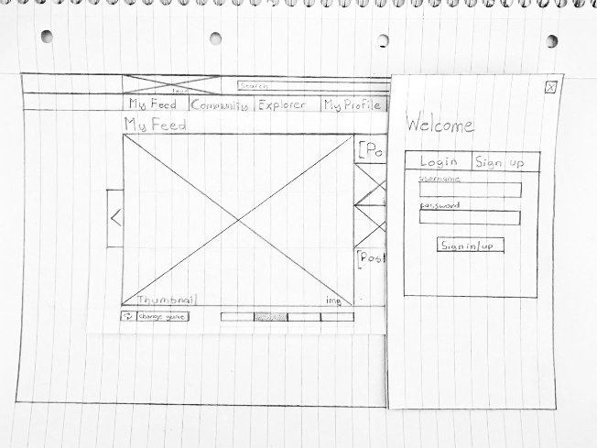

Login/Sign Up Tab

Community Page

Profile Page

Explorer Page

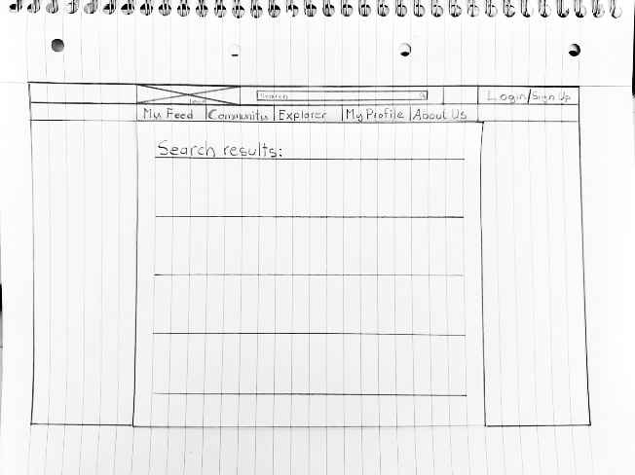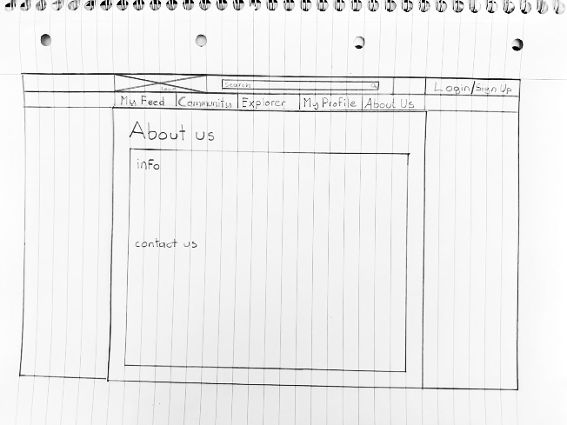

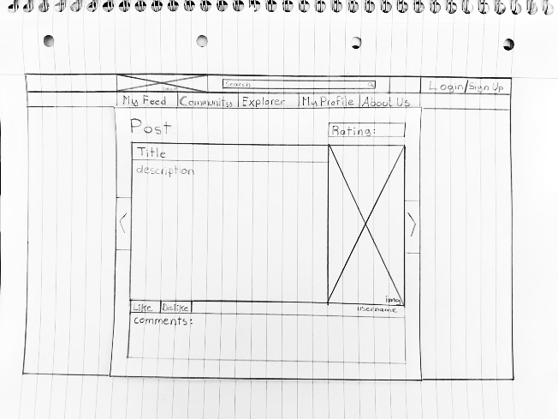

Post Page

Search Results Page

About Us Page

## Colour scheme

Posts Page

## Meeting Records

Meeting 1

|  |  |
| --- | --- |
| Date | 20/02/2025 |
| Meeting goals | Finalize project scope  Assign initial roles and tasks  Set up GitHub repository and Kanban board |
| Attendees | Bradley Torres, Anthony White |
| Roundup updates | Brainstormed project ideas  Agreed on the initial scope |
| Discussion | Different project ideas were considered  Feasibility and scope of each idea were analyzed  Agreement on a final project concept |
| Actions | To set up the GitHub repository  To create the Kanban board  To document the project scope |

Meeting 2

|  |  |
| --- | --- |
| Date | 21/02/2025 |
| Meeting goals | Review GitFlow workflow and Docker setup  Start work on frontend and backend structure |
| Attendees | Bradley Torres, Anthony White |
| Roundup Updates | Discussed and reviewed the GitFlow workflow  Set up Docker environment |
| Discussion | Best practices for using GitFlow  Initial structure and design of frontend and backend |
| Actions | To document GitFlow workflow  To complete Docker setup  To begin frontend development  To start backend API development |

Meeting 3

|  |  |
| --- | --- |
| Date | 23/02/2025 |
| Meeting goals | Discuss user personas and ethical considerations  Update project documentation  Review project progress |
| Attendees | Bradley Torres, Anthony White |
| Roundup Updates | Created user personas  Analyzed ethical concerns related to the project |
| Discussion | Consideration of accessibility and inclusivity in design  Updating documentation based on recent developments |
| Actions | To finalize user personas  To update project documentation  To review progress and ensure alignment with project goals |